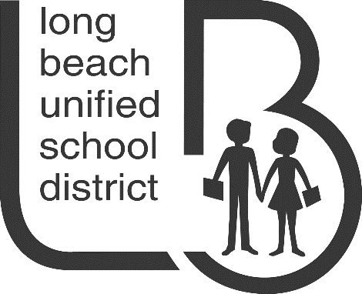

CURRICULUM, INSTRUCTION & PROFESSIONAL DEVELOPMENT
Science Curriculum Office
Teacher Resource Center, Room 7
1299 E. 32nd Street, Signal Hill, CA 90755
(562) 997-8000 Ext. 2963 FAX: (562) 426-8448

Please return your completed form ASAP

by mailing to the address listed above or

faxing to 562/426-8448
or email mchambliss@lbschools.net

REVIEWER VOLUNTEER FORM

SCIENCE & ENGINEERING FAIR 2020
25th ANNUAL LONG BEACH UNIFIED SCHOOL DISTRICT SCIENCE FAIR

Please “X” below where appropriate.
YES. I would like to participate as a reviewer for the Long Beach Unified School District Science Fair on Saturday, MAY 16, 2020. Reviewer commitment is 8:45 a.m.--12:00 noon
I am a returning Reviewer from last year or a previous year’s Science Fair.
Approximately how many years have you reviewed for us? years
I am a first-time Science Fair Reviewer.
No, I am NOT able to participate as a reviewer this year.
Keep me on the list and contact next year.

Please print.
Name:
Title: |  |  |  |  |  |  | Employer, School or Office:
Preferred Mailing Address:
City: |  |  |  |  | Zip Code: |  |  |  | Best Phone #:
Email : |  |  |  |  |  |  |  |  | Fax # (optional):
Languages spoken (other than English):
Category Preference: |  |  | No Preference Elementary (Gr. K-5) Secondary (Gr. 6-12)

Do you know any colleagues who might like to be Reviewers? If so, please forward this letter & form to them, or list their name and email address or phone number below so we can get an invitation letter & form to them. Thank you!

If you would like us to acknowledge your participation to your supervisor, please complete all sections below:
Supervisor‘s Name:
Supervisor’s Title:
Company (or School):
Address:
City, State & Zip Code:

